# CACCC Resource Database Documentation - Table of Contents

Table of Contents 1

CACCC Resource Database Documentation - Usage 2

How to connect to the database 2

The Main Page – “Resource List” 2

The “Add a Resource” Page 3

The “Edit Resource” Page 3

CACCC Resource Database Documentation – Maintenance 5

Prerequisite Software 5

Updating prerequisite software 5

First time installation 5

Folder structure & how updating works 5

How to start the database 6

How to find the IP address of the machine running the database 7

Troubleshooting Errors 8

# CACCC Resource Database Documentation - Usage

## How to connect to the database

1. Open a web browser on your computer.
2. In the address bar, type the address of the computer hosting the database followed by :3000.  
   Currently this would be, **[type address here]**It’s recommended that everyone keeps this as a bookmark, so they don’t have to remember this.
3. If the address is unknown, see “How to find the IP address of the machine running the database” in the maintenance documentation.

## The Main Page – “Resource List”

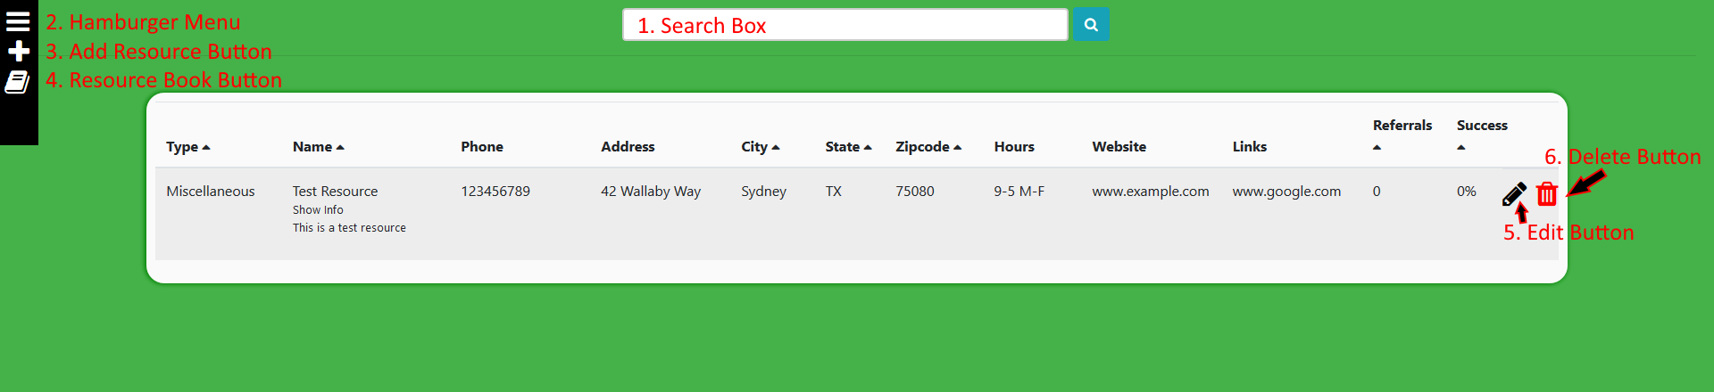

1. **Search Box** – You can type something here to try and find a specific resource. It searches by Name, Type, Address, Phone, Zip Code, City and Website all at once. You can type any of those in to find what you’re looking for. This will always be at the top of the page no matter where you are on the site.
2. **Hamburger Menu** – Click this to expand the menu on the left. It will reveal an option so filter the resources by type. This menu will stay here no matter where you go on the site.
3. **Add Resource Button** – Clicking this will take you to the “Add a Resource” page.
4. **Resource Book Button** – Clicking this will take you back to the “Resource List” page and reset all type filters/search results.
5. **Edit Button** – Clicking this will take you to a new page to let you edit that resource and to submit a referral.
6. **Delete Button** – Clicking this will delete a resource. This is permanent, but it will prompt you to ask if you’re sure.
7. Extra notes: You can click any of the column titles with a triangle next to them to sort by that column. Also, if you hover over “Show Info” it’ll expand like in the picture above and show the resource description.

## The “Add a Resource” Page

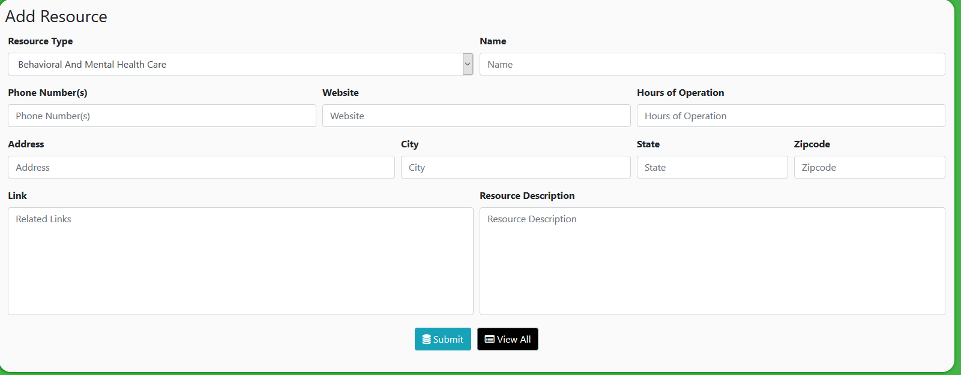

Here you can create a new entry into the database. Fill out whatever information you need to (doesn’t have to be everything!) and click submit to save into the database. Clicking “View All” will take you back to the main page and discard whatever you were working on.

## The “Edit Resource” Page

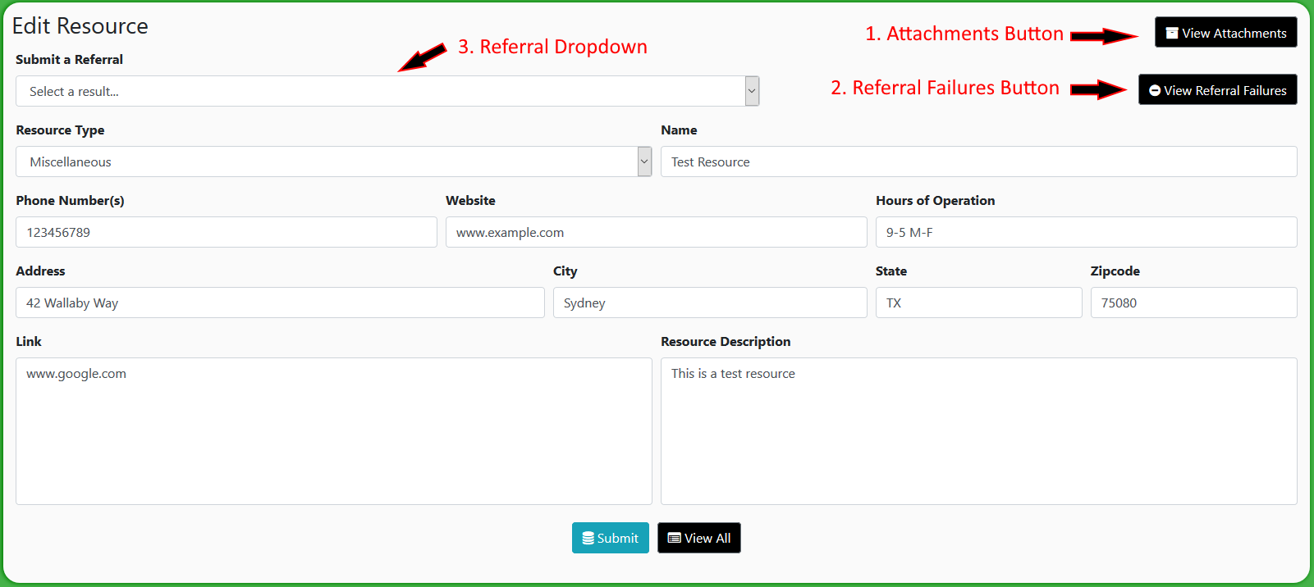

This page is similar to the “Add a Resource” Page, with a few additions:

1. **Attachments Button** – This will take you to a page where you can view/upload files that correspond to the resource (like flyers, pictures, etc.).
   1. **View of the attachments page**: 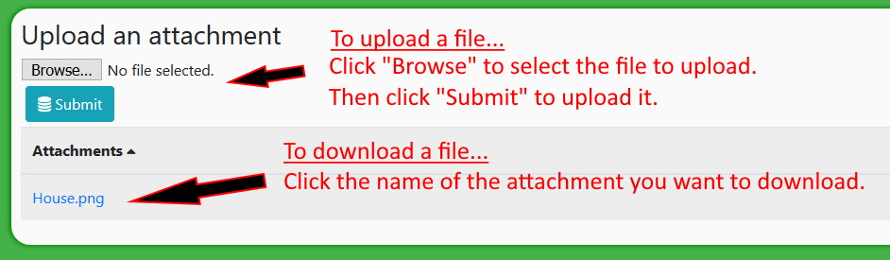
2. **Referral Failures Button** – Clicking this will display a small window detailing how many/what kinds of reasons people have had their referrals fail.
3. **Referral Dropdown** – Selecting this will display a bunch of results of a referral. If you don’t select anything, a new referral will not be submitted. If you select “successful,” a successful referral will be submitted. If you selected anything prefixed with “Failed:” a failed referral will be submitted. The system keeps track of how many referrals of each category were submitted.
4. Notes: remember, nothing will change until you click the “Submit” button. Marking a referral or making any edits will not do anything until the submit button is clicked.

# CACCC Resource Database Documentation – Maintenance

## Prerequisite Software

|  |  |
| --- | --- |
| **Software Name** | **Current Version** |
| MongoDB | 4.2.3 |
| Python | 3.8.1 |
| Node.js | 12.14.1 |
| Git | 2.25.0 |

## Updating prerequisite software

* **MongoDB**: after updating, making sure that in Settings.txt, the “Mongo Path” line contains the path for the new mongod.exe file.
* **Python/Node.js/Git**: Make sure that these executables are updated in the PATH environment variable.

## First time installation

* Install all the prerequisite software and make sure that python, node.js, and git were all added to the PATH environment variable correctly (already installed on the PC from EPICS).
* Run the “Create.bat” file.
* Follow the steps in “how to start the database” to set up automatic startup/updating (already set up on the PC from EPICS)
* Either restart the computer or run “startandupdate.bat” to start up the server.
* Look at “how to find the IP address for the machine running the database” if the IP of the host machine is unknown.

## Folder structure & how updating works

Everything related to the database is contained in a folder called “caccc_deploy”. Inside this folder, there are a few other files/folders that run the database.

* The “repo” folder
  + This contains all of the executable files that run the server.
  + It does not and never should contain any files that need to be save.
  + It is overwritten every time the server is updated with the latest version from the github repository (<https://github.com/utdEPICS/CACCC_Resource_Database>)
  + “start routine.zip” contains all the files needed to use the auto updater in case they get lost.
* Startandupdate.bat
  + Batch file that runs at startup. Runs update.bat then start.py to update then start the server.
* Update.bat
  + Triggered by startandupdate.bat. Updates the server by pulling from the github repository (<https://github.com/utdEPICS/CACCC_Resource_Database>)
* Start.py
  + Triggered by startandupdate.bat. Replaces that start.bat file in repo/CACCC_Resource_Database/resource_database to match the settings provided by settings.txt, then runs it.
* Manualstart.bat
  + You can run this to manually start the server if needed. Uses Start.py.
* Create.bat
  + Initializes and clones the repository in repo. Run this if the repo folder ever gets deleted.
* Settings.txt
  + Provides arguments to the server (like where the database files are, where the mongoDB executable is, etc.)
  + Each argument should be separated by a newline. Each line should have the format *argument name:* ***value***
  + Invalid lines are ignored, and a default value is used.
  + Possible settings:
    - uploadPath – path to store/read attachments to resources (default: ../../assets/attachments)
    - mongoPath – path to MongoDB executable for the server to startup (default: C:/Program Files/MongoDB/Server/4.2/bin/mongod.exe)
    - dbPath – path to store/read resource database entries (default: ../../db_files)
    - dontStartMongo – whether the server should automatically start up mongodb (default: false)
* Updating
  + The batch file “startandupdate.bat” should run at startup. It runs update.bat then start.py
  + Update.bat pulls from the github repository (<https://github.com/utdEPICS/CACCC_Resource_Database>) to overwrite the repo folder.
  + Then, start.py overwrites the start.bat file (in repo/CACCC_Resource_Database/resource_database) to place the proper settings. Next, it runs start.bat.
  + The server is now updated the running on the machine

## How to start the database

The database should start automatically when the computer starts up. If not, you can run manualstart.bat. However if it stops automatically starting up, try this,

1. Press the Windows key and R at the same time to open the “Run” dialog.
2. Type shell:startup in the dialog and hit enter. 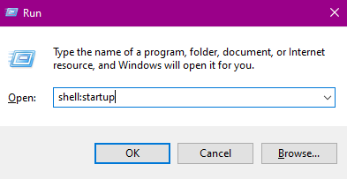
3. Create a shortcut to “startandupdate.bat” and place it in the folder that opens up.  
   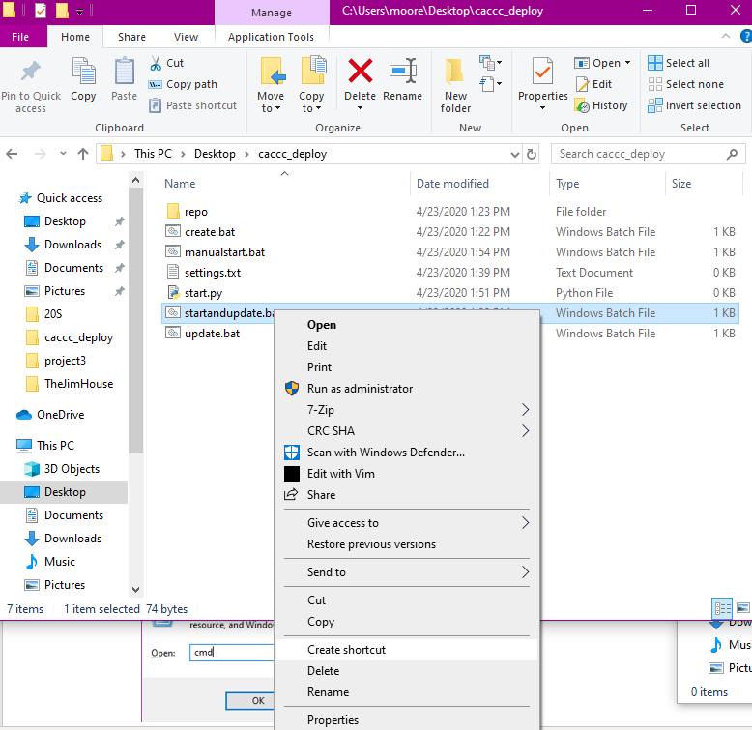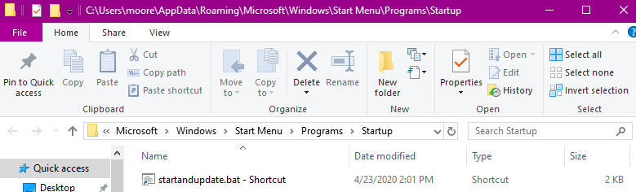
4. Now the server should start when the computer starts up.

## How to find the IP address of the machine running the database

1. To find the address, go to the computer hosting the database. Press the Windows key and R at the same time. In the dialog that opens up, type “cmd” and click ok. 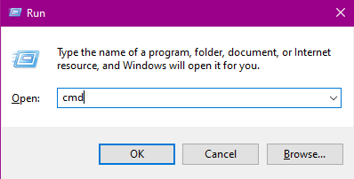
2. Now, in the window that opens up, type “ipconfig” (without the quotes) and hit enter. You want the IPv4 address (pictured below). Your address will be different than mine.  
   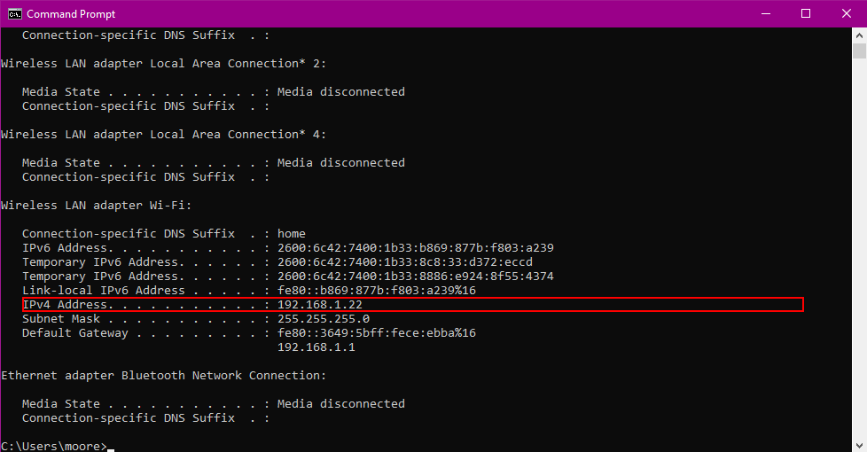
3. Remember to add :3000 to the end of the address! In this example, it would be **192.168.1.22:3000**

## Troubleshooting Errors

* Error in DB Connection : MongoNetworkError: failed to connect to server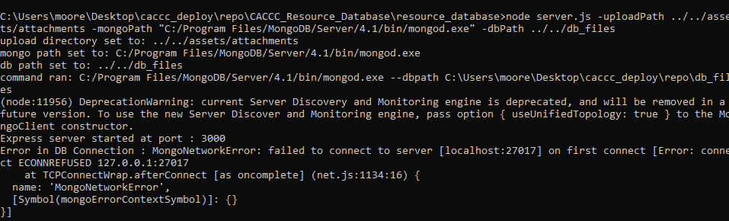
  + This means that the resource database was not able to connect to MongoDB.
  + Usually, this means that MongoDB was not started up with the server. Make sure that in “settings.txt” the Mongo Path option points to the MongoDB executable in the right folder (usually it’s named mongod.exe in C:\Program Files\MongoDB\Server\4.2\bin). The 4.2 may change in the future depending on updates.
  + If this doesn’t work, check the firewall settings.
  + If there’s no issue there, delete the repo folder and run create.bat to refresh the server files.
* No one can connect to the database
  + Make sure the IP address of the host computer has not changed.
  + Make sure there are no errors in the server console.
  + Try restarting the server/computer.
  + Check to see if the host computer is plugged into the right network (not law enforcement)
  + Check the firewall and make sure node.js has access to networking